Lab Report

Your Information
Your Name: Joshua Zimmerman-Gibson
Assignment Title: Advanced Excel Data Analysis

Screenshots
Task 1: Data Cleaning and Standardization
Step 1.1: Remove Duplicates
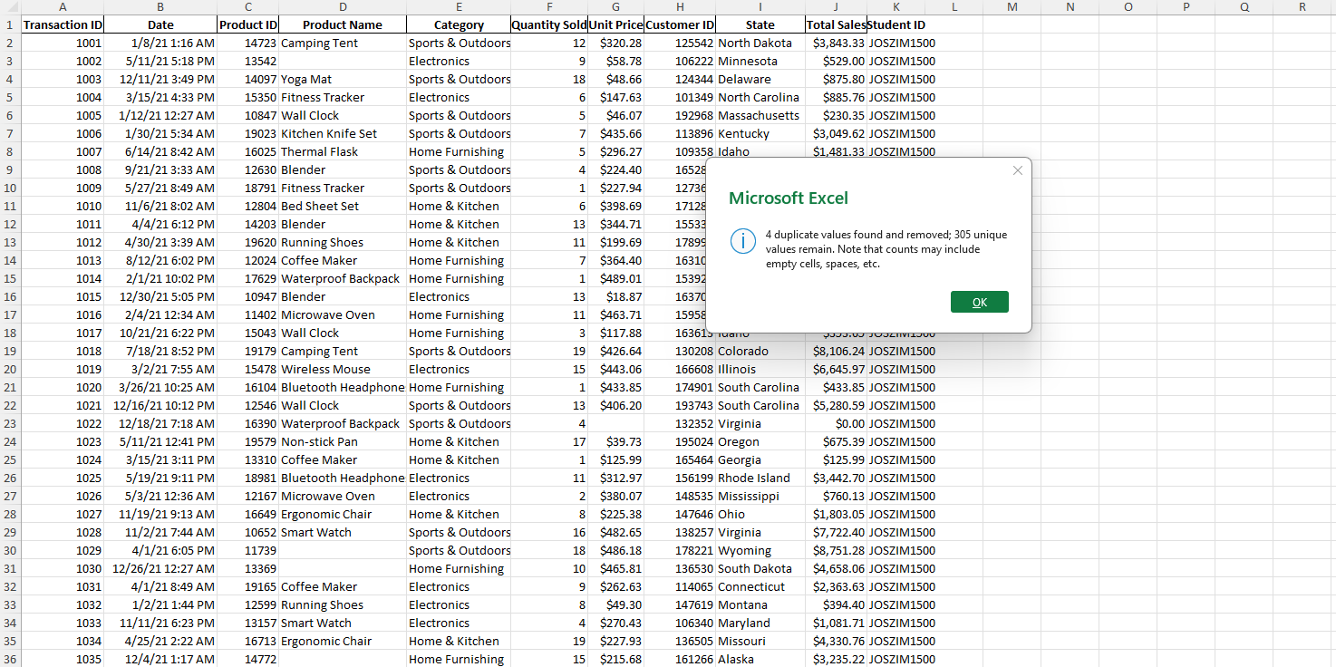
Step 1.2: Fill in Missing Values
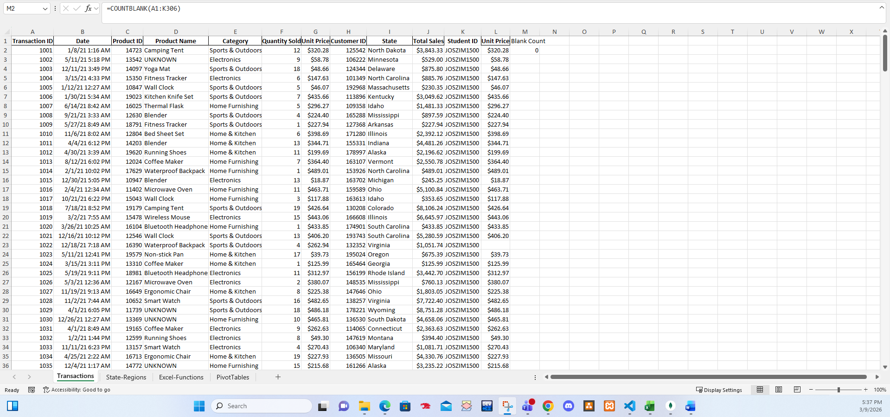
Task 2: Advanced Excel Functions
Step 2.1: Using VLOOKUP to Add the “Region” Column
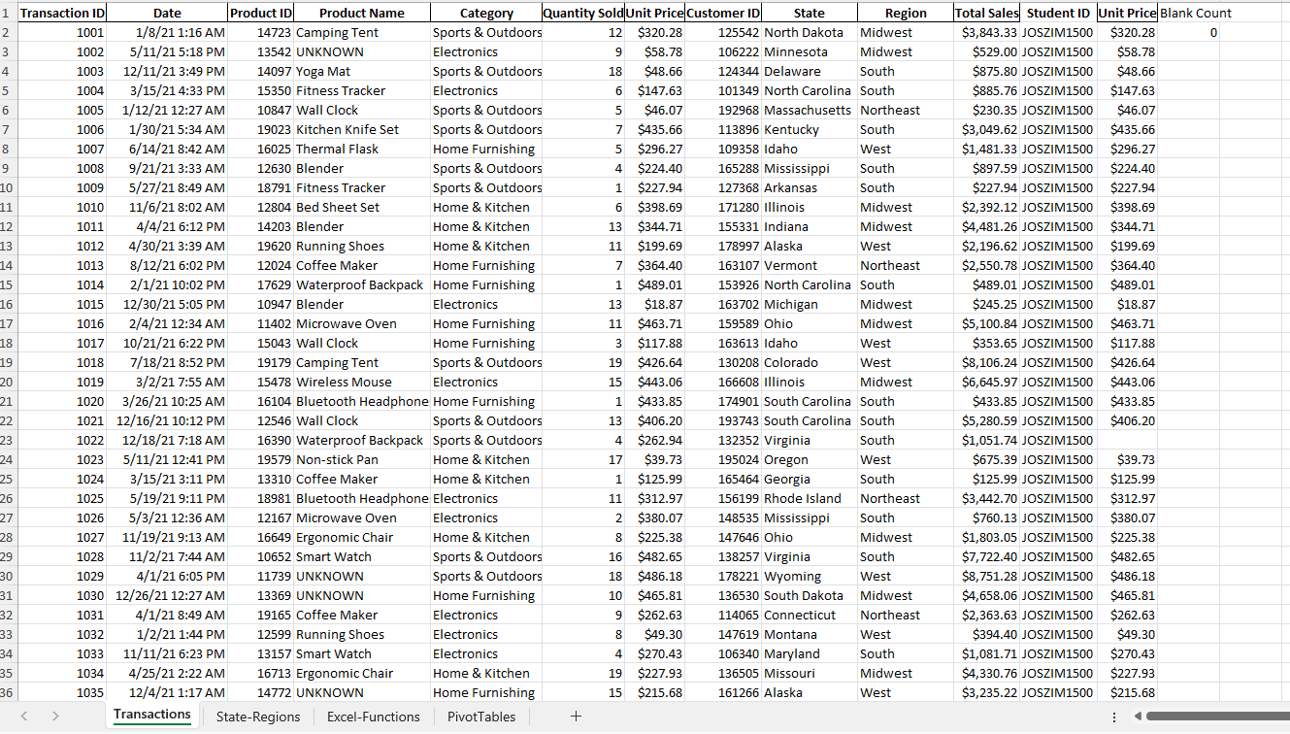
Step 2.2: Using SUMIFS for Multi-Criteria Sales Analysis
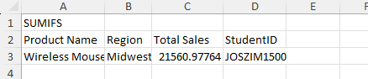
Step 2.3: Using COUNTIFS for Counting High-Value Transactions
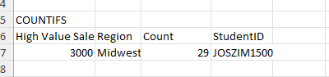
Step 2.4: Using AVERAGEIFS for Calculating Average Sales
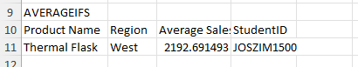
Task 3: Creating Pivot Tables for Analysis
Step 3.1: Pivot Table for Sales by Category and Region
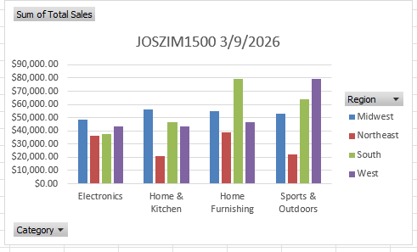
Step 3.2: Pivot Table for Top-Selling Products
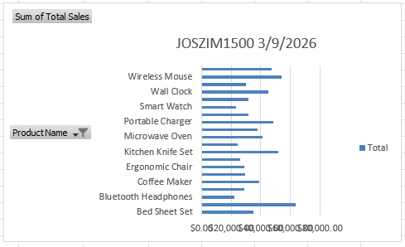
Step 3.3: Advanced Pivot Table for Regional Sales Comparison
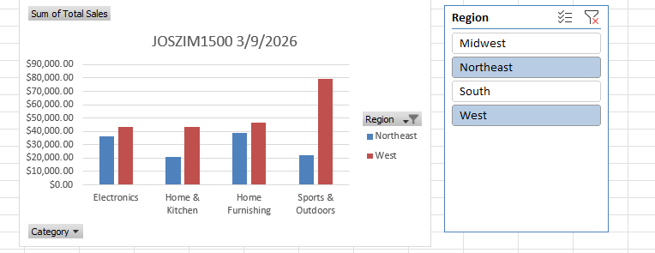

Questions
1. Why is creating a Pivot table an effective way to analyze data in Excel, and how does it help in summarizing information for better insights?
PivotTables in Excel are a super helpful tool because they let you quickly make sense of lots of data without doing a ton of manual work. Imagine you have a big list of sales information, like dates, products, regions, and how much money was made. Instead of adding everything up by hand or writing complicated formulas, a PivotTable does it for you in just a few clicks. It takes all that messy, detailed data and turns it into clear, organized summaries.

The best part is how easy it is to change what you’re looking at. You simply drag and drop different categories (like “Region” or “Product”) into different spots, and the numbers update instantly. Want to see total sales by month? Drag the date there. Want to compare regions? Move “Region” to the columns. You can switch views in seconds without starting over or fixing formulas. This makes it simple to explore your data from different angles and spot patterns or problems fast.

PivotTables also help you find useful answers quickly and accurately. They can show totals, averages, counts, or even percentages, like which product sells the most, which month was the busiest, or what percentage of sales came from each area. Because everything is calculated automatically, you avoid mistakes that happen when you do math by hand. Plus, when new data gets added, you just click “refresh” and the PivotTable updates.

In short, PivotTables save time, reduce errors, and make it much easier to understand what your data is really telling you. They turn a long list of numbers into simple, meaningful summaries that help you make better decisions, whether you’re running a business, tracking expenses, or just trying to figure out what’s going on in a big spreadsheet.

2. In Step 3.1, we created a Pivot table to analyze total sales by product category and region. Can you explain the significance of this analysis and how it can benefit businesses?
We can quickly see patterns like:
- The South region has the highest overall sales ($227,010), driven strongly by categories like Sports & Outdoors and Home & Kitchen.
- Home Furnishing is a top performer across most regions, especially in the South.
- The Northeast has the lowest total sales ($118,380), and categories like Electronics and Sports & Outdoors are much weaker there compared to other regions.
- The Midwest leads in Electronics sales.
This kind of breakdown helps businesses spot what's working well and what isn't.
Here are some key benefits for businesses:
1. Identify top-performing regions and categories Businesses can see which areas and products bring in the most money. For example, they might decide to put more marketing effort or inventory into Sports & Outdoors in the South, where it sells best.
2. Find underperforming areas Low sales in the Northeast for certain categories could mean the company needs to investigate, maybe run promotions, train staff better, adjust pricing, or even rethink which products to offer there.
3. Make smarter inventory and supply decisions Knowing that Home Furnishing sells strongly everywhere helps avoid running out of stock in high-demand regions, while reducing excess stock of slow-moving items in weaker areas.
4. Guide marketing and sales strategies Companies can target ads or sales campaigns to the right places and products. For instance, push Electronics harder in the Midwest where it performs well, rather than spreading budget evenly.
5. Spot opportunities for growth If one category does great in some regions but poorly in others, there might be a chance to expand successful products into weaker markets.
6. Improve overall profitability By focusing resources on high-performing combinations (like strong categories in strong regions), businesses can increase sales without spending much more money.

3. In Step 3.2, we identified the top-selling products based on quantities sold and total sales
value. Why is understanding top-selling products important, and how can this information
guide marketing and sales strategies.
Knowing your top-selling products (based on total sales value and quantities sold) is one of the most valuable pieces of information a business can have. In your PivotTable, products like Bed Sheet Set (leading at $34,812.94), Blender ($63,848.05), Kitchen Knife Set, Portable Charger, and others stand out as the biggest revenue generators, while lower ones trail behind. This ranking shows exactly where the money is coming from.
Understanding these top performers is important because:
- It highlights what customers actually want and are willing to pay for right now.
- A small number of products often drive most of the revenue (this is the classic 80/20 rule, or Pareto principle, about 20% of items generate 80% of sales).
- It prevents wasting time, money, and storage space on slow-moving items.
- It helps spot trends early, so the business can capitalize on what's hot before it fades.
This information directly guides marketing and sales strategies in practical ways:
1. Focus marketing budget on winners Put more effort into promoting top sellers like the Bed Sheet Set, Blender, and Kitchen Knife Set. Run targeted ads, email campaigns, social media posts, or influencer partnerships featuring these items to drive even more sales. For example, highlight customer reviews or bundle them with related products.
2. Create promotions around high-performers Offer discounts, "buy one get one" deals, free shipping, or limited-time bundles on top items to boost volume without hurting profits much (since these already sell well).
3. Upsell and cross-sell smartly Recommend related top sellers at checkout, like suggesting a Blender with a Coffee Maker or Portable Charger with a Smart Watch, to increase average order value.
4. Optimize inventory and avoid stockouts Stock up heavily on best-sellers to prevent running out (which loses sales), while ordering less of low performers to free up cash and space.
5. Test new ideas based on what's working If kitchen items like blenders and knife sets are strong, introduce similar new products (e.g., other appliances or tools) and promote them to the same audience.
6. Adjust pricing or positioning If a top item like the Bed Sheet Set has high volume but lower price, consider a premium version or bundle to increase profit per sale.

